# Corporate Employee Attrition Analysis

**A PROJECT REPORT**

Submitted By

# Team ID: PNT2022TMID53453

**Team Leader: DAKSHIN ARAVIND M**

**Team Member: HARSHA VARDHAN U**

# Team Member: ROBIN THOMAS T

# Team Member: BARATH J

in partial fulfillment for the award of the degree of

# BACHELOR OF ENGINEERING

IN

# INFORMATION TECHNOLOGY

# SRI VENKATESWARA COLLEGE OF ENGINEERING

**ANNA UNIVERSITY: CHENNAI 600025**

# 

**TABLE OF CONTENTS**

# CHAPTER NO TITLE PAGE NO

1. INTRODUCTION 4
   1. Project Overview **4**
   2. Purpose **4**
2. LITERATURE SURVEY 5
   1. Existing problem **5**
   2. References **5**
   3. Problem Statement Definition **5**
3. IDEATION & PROPOSED SOLUTION
   1. Empathy Map Canvas **6**
   2. Ideation & Brainstorming **7**
   3. Proposed Solution **7**
   4. Problem Solution fit **8**
4. REQUIREMENT ANALYSIS
   1. Functional requirement **9**
   2. Non-Functional requirements **9**
5. PROJECT DESIGN
   1. Data Flow Diagrams **11**
   2. Solution & Technical Architecture **11**
   3. User Stories **12**
6. PROJECT PLANNING & SCHEDULING
   1. Sprint Planning & Estimation **13**
   2. Sprint Delivery Schedule **14**
   3. Reports from JIRA **14**
7. CODING & SOLUTIONING 15
8. TESTING
   1. User Acceptance Testing **17**

**8.2** Model Performance Testing **19**

1. RESULTS 25
2. ADVANTAGES & DISADVANTAGES 25
3. CONCLUSION 28
4. FUTURE SCOPE 29
5. APPENDIX 29

# 1. INTRODUCTION

# Project overview

Employee attrition has become a vital problem across the world. It is one of the crucial issues faced by business leaders within companies where they lose the most talented employees. A good employee is always an asset to the organization and their resignation can lead to various problems like financial losses, overall performance, and loss of acquired knowledge. Furthermore, hiring new employees is far exorbitant, taxing, and time-consuming in comparison to recruiting the existing one. It is very time-consuming to recruit a new employee as it takes him months for training, adjusting to the culture, rules, and environment. Therefore, upcoming trends and technology using Machine Learning Algorithms must be exploited for the benefit of business organizations. Knowing the reason beforehand for the employee attrition, companies can mitigate this loss. This analysis provides a conclusive review of employee attrition from the data set IBM HR Analytics Employee Attrition Performance.

# Purpose

* + 1. Hardik P. K. (2016), researched on “a study on employee attrition: with special reference to Kerala IT Industry”. His research examined the relationship between organizational factors and attrition of IT professionals. The result can conclude that the organizational factors played significant role in predicting the variance in turnover intention (attrition) of Kerala IT professionals. Therefore, the HR managers in IT organizations may take into consideration the problems with organizational

factors of their workers to reduce the turnover intention of the skilled employees**.**

# LITERATURE SURVEY

# Existing Problem

The Existing system includes only few attributes for analysis and also deals with qualitative observations and simple statistical analysis. The qualitative observations deal with data and can be observed through human senses. They do not involve measurements or number. Due to the increase in IOT and connected device, we now have access to so much of data and along with it an increase needs to manage and understand data.

# References

* + 1. From Big Data to Deep Data to support people analytics for employee attrition prediction, Nesrine Ben Yahia, Hlel Jihen, Ricardo Colomo-Palacio( 2021)
    2. Machine Learning Approach for Employee Attrition Analysis.

R. S. Kamath | Dr. S. S. Jamsandekar | Dr. P. G. Naik, Published in International Journal of Trend in Scientific Research and Development (ijtsrd), (March 2019)

* + 1. Investigation of early career teacher attrition (ECT) and the impact of induction programs in Western Australia, Janine E.Wyatt, MichaelO’Neill (2021)

# Problem Statement Definition

* To create a dashboard and perform analysis of employee attrition in corporates using IBM Cognos analytics platform.
* To reduce the employee attrition rate through data analytics,

data visualization by analyzing the major factors that causes attrition.

# IDEATION AND PROPOSED SOLUTION

# Empathy Map Canvas

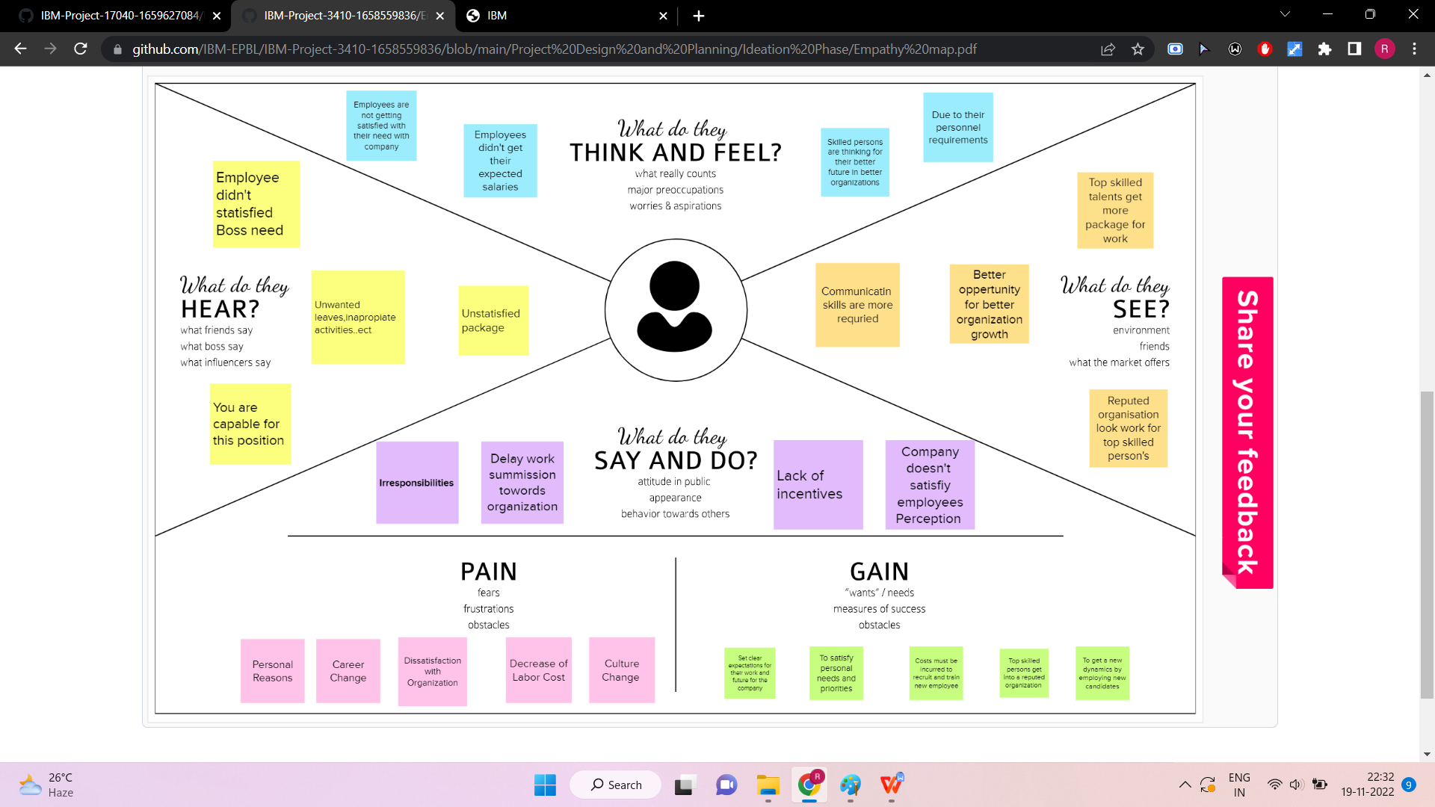

# Ideation & Brainstorming

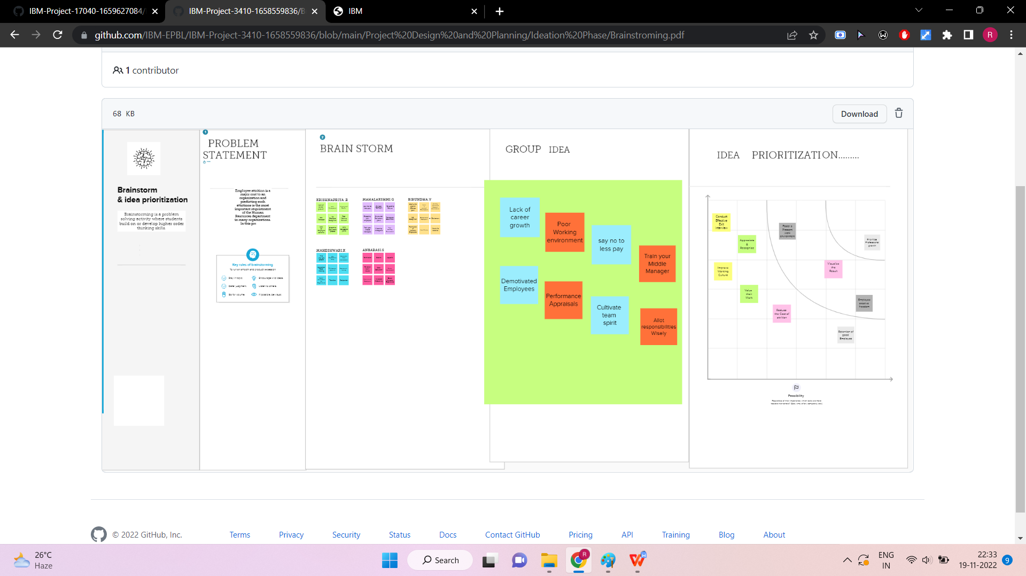

# Proposed Solution

Foster a pleasant Work Environment

The Work Environment is the space where employees fulfill their job responsibilities

Appoint the right leadership

# Problem Solution fit

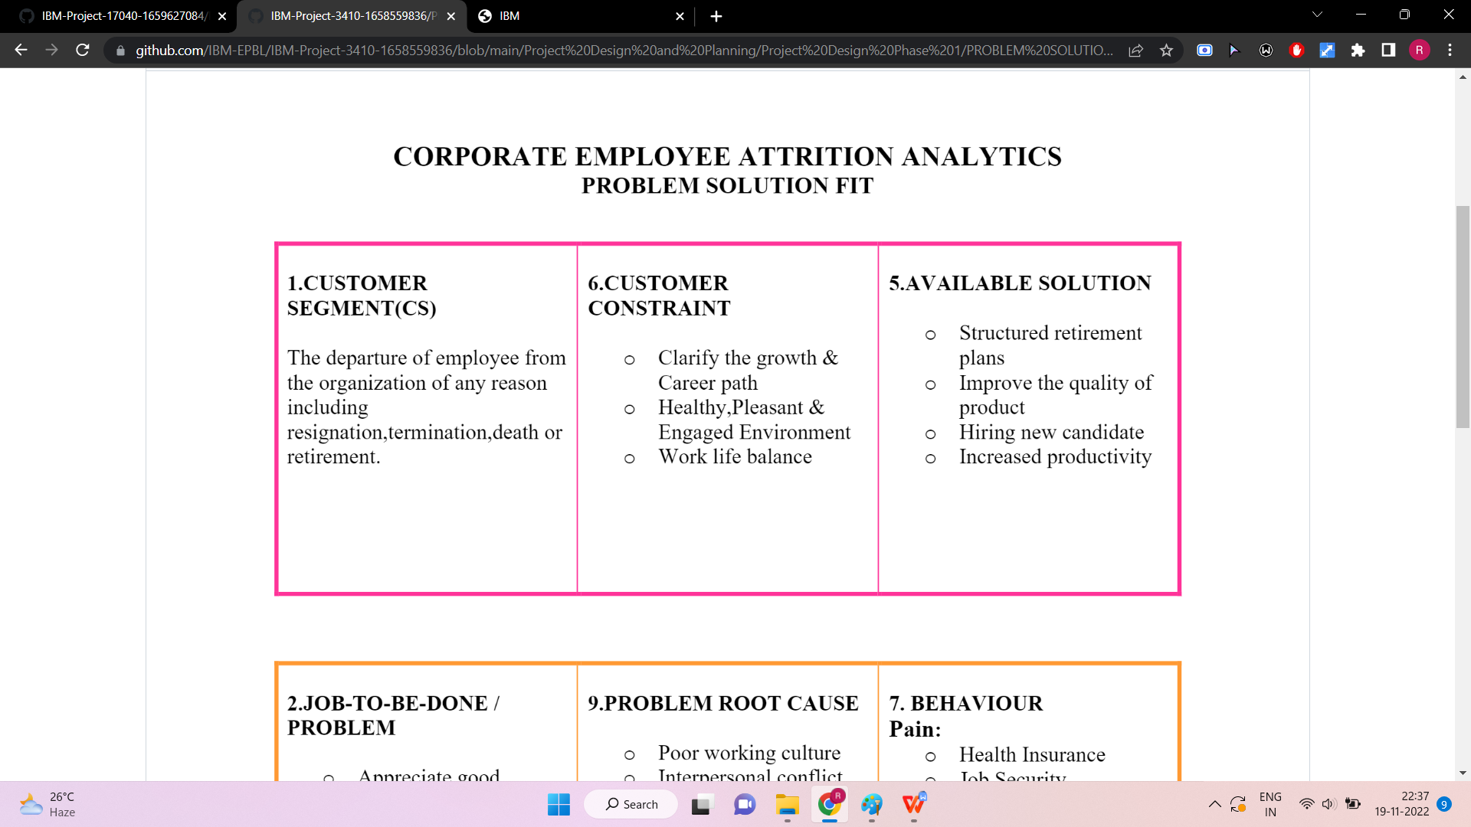

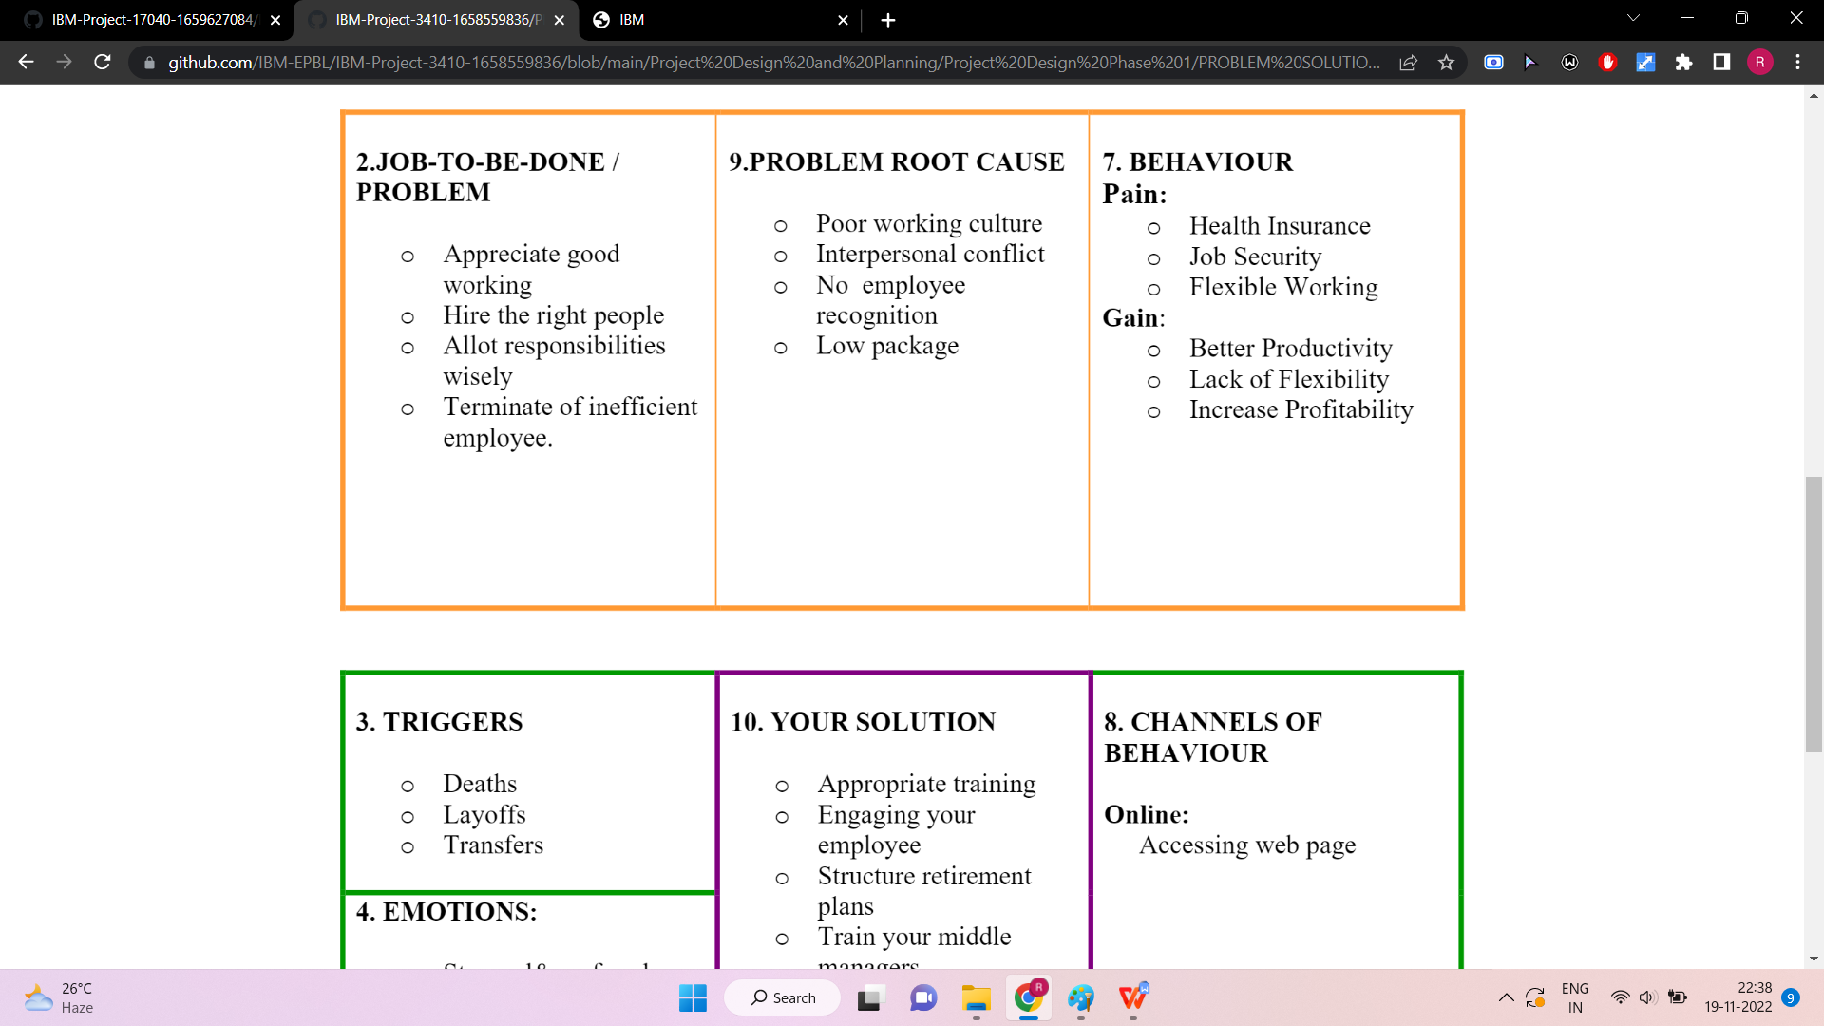

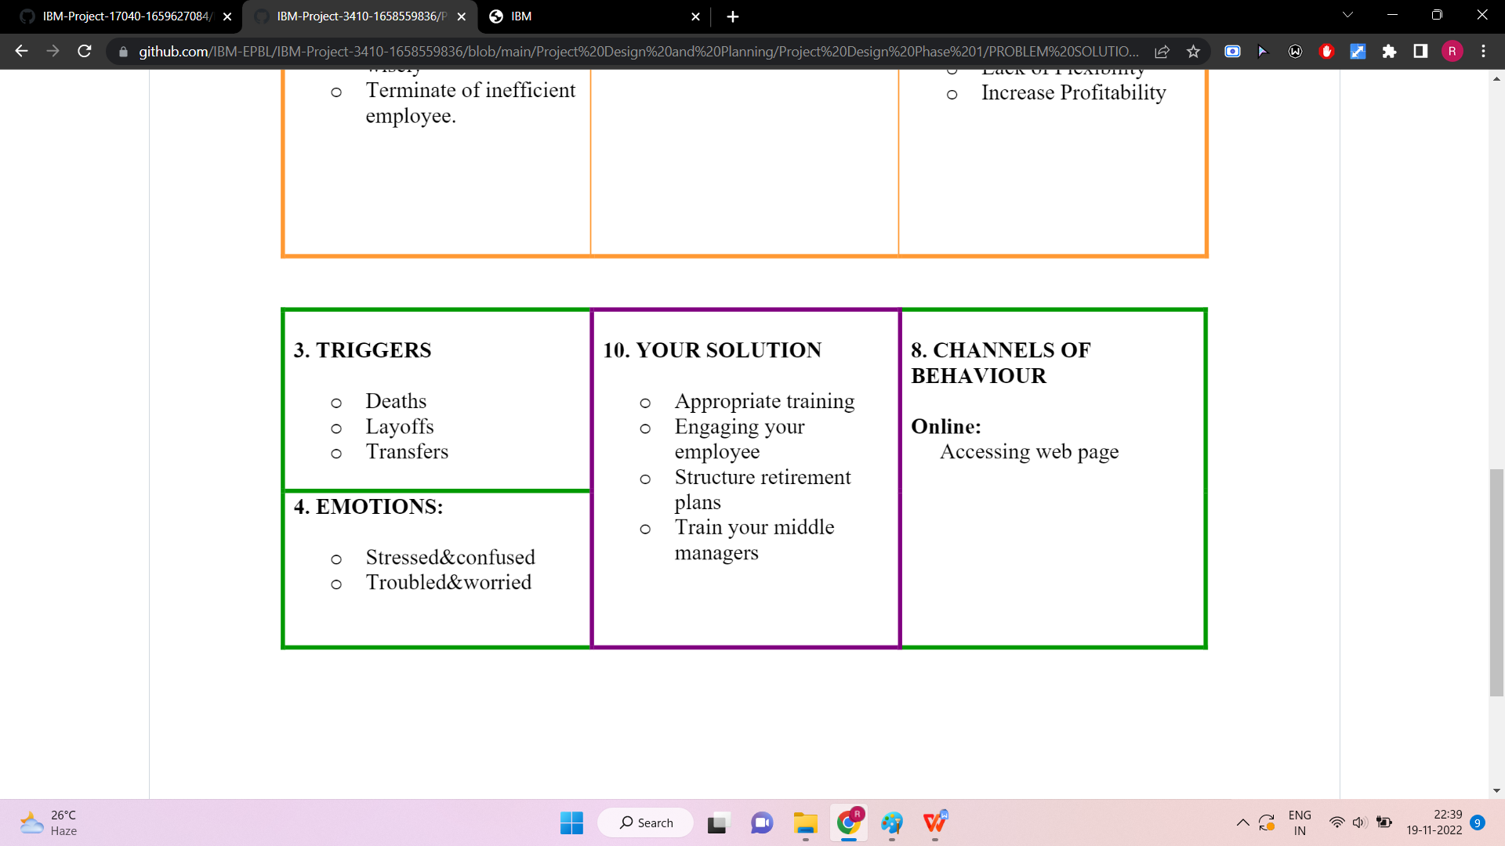

# REQUIREMENT ANALYSIS

# Functional requirement

|  |  |  |
| --- | --- | --- |
| **FR No.** | **FunctionalRequirement(Epic)** | **SubRequirement(Story/Sub-Task)** |
| FR-1 | UserRegistration | RegistrationthroughForm |
| FR-2 | UserConfirmation | ConfirmationviaEmail |
| FR-3 | User Authentication | Authenticatetheuser’sattempttologinusingthe database |
| FR-4 | Retentionanalysis | Employeeattritionanalysisbysentiment, work environment,dailycontributionetc. |
| FR-5 | Employeemanagement | Validatingandmanagingthe registeredemployee details. |
| FR-6 | Progressmanagement | Addthe progressofeachemployeeto thecompany. |
| FR-7 | Predictbutton | The predict route is used for prediction and it containsall the codes which are used for predicting our results.Firstly, inside launch function we are having thefollowingthings:   * Gettingour inputandstoringit. * Select the necessary attributes for theprediction. * Creatingmodel. * Predictingourresults. * Showcase the results with the help ofdashboard. * Finallyruntheapplication. |

# Non-Functional requirements

Following are the non-functional requirements of the proposed solution.

|  |  |  |
| --- | --- | --- |
| **FR No.** | **Non-FunctionalRequirement** | **Description** |
| NFR-1 | **Usability** | This software shall be easy to use for all users withminimalinstructions.100%ofthe  languages on the graphical user interface (GUI) shallbe intuitiveandunderstandable by  non-technicalusers. |
| NFR-2 | **Security** | The user of the system should be provided thesuretythattheiraccountdetailsare secure.The system will provide security against cross siterequestforgery. |

|  |  |  |
| --- | --- | --- |
| NFR-3 | **Reliability** | The software shall be operable in all conditions. Thesystemmust beless pronetoerrors. |
| NFR-4 | **Performance** | Theperformanceofthesystemmustassist the system’squality. |
| NFR-5 | **Extensibility** | The software shall be extensible to support futuredevelopmentsandadd-ons. |
| NFR-6 | **Portability** | The software shall be 100% portable to alloperating platforms. Therefore, this softwareshouldnotdependonthedifferent  operatingsystems. |
| NFR-7 | **Scalability** | Thesystemmustbeableto handleanincreasein workloadwithoutperformance degradation. |

# PROJECT DESIGN

# Data Flow Diagrams

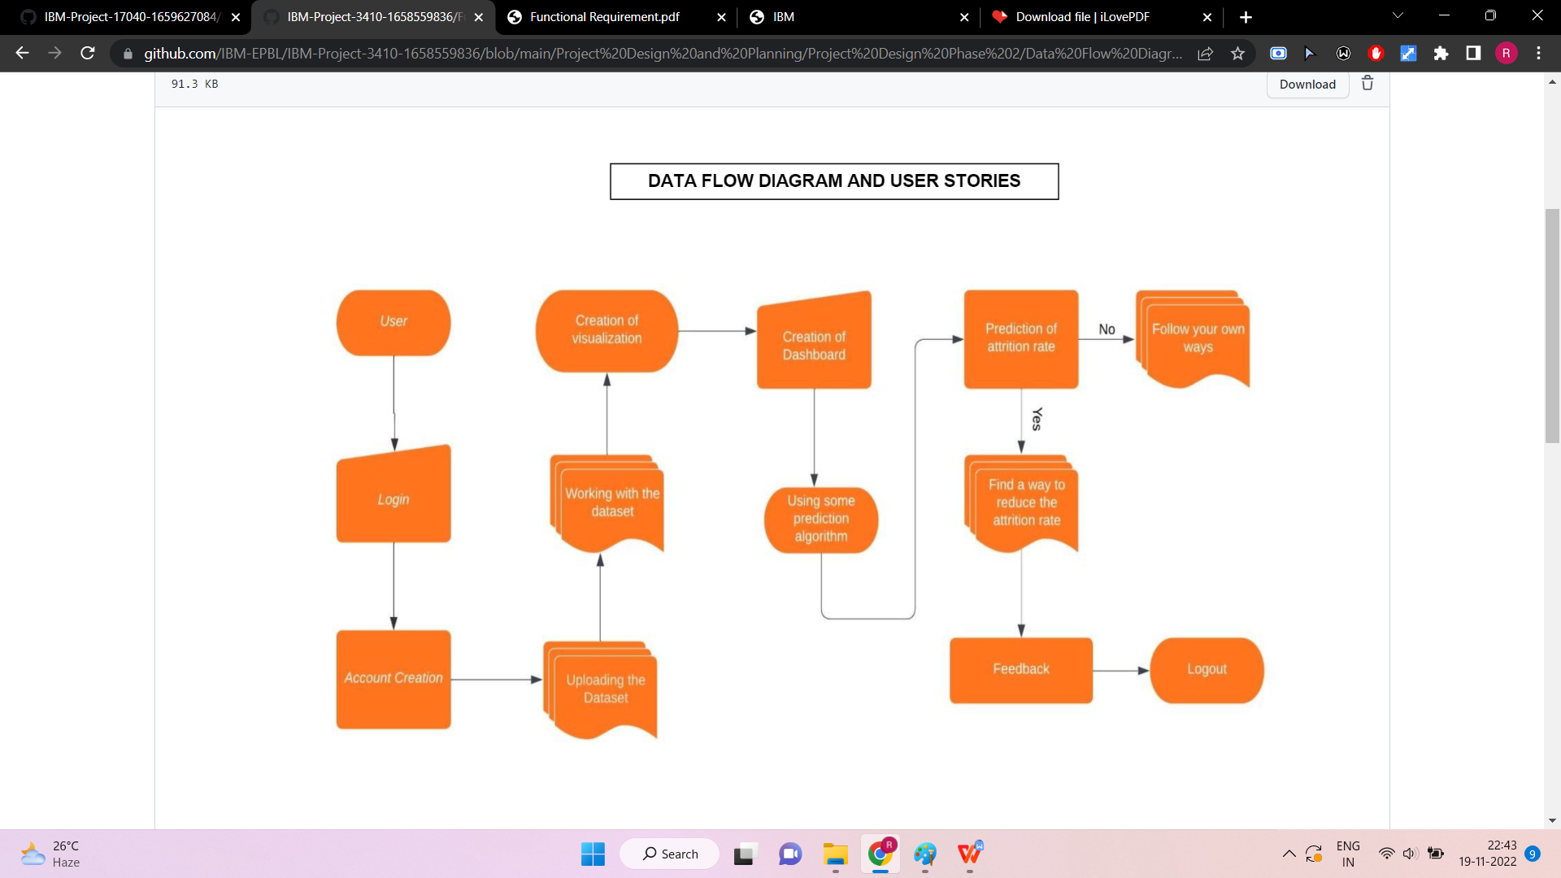

# Solution & Technical Architecture

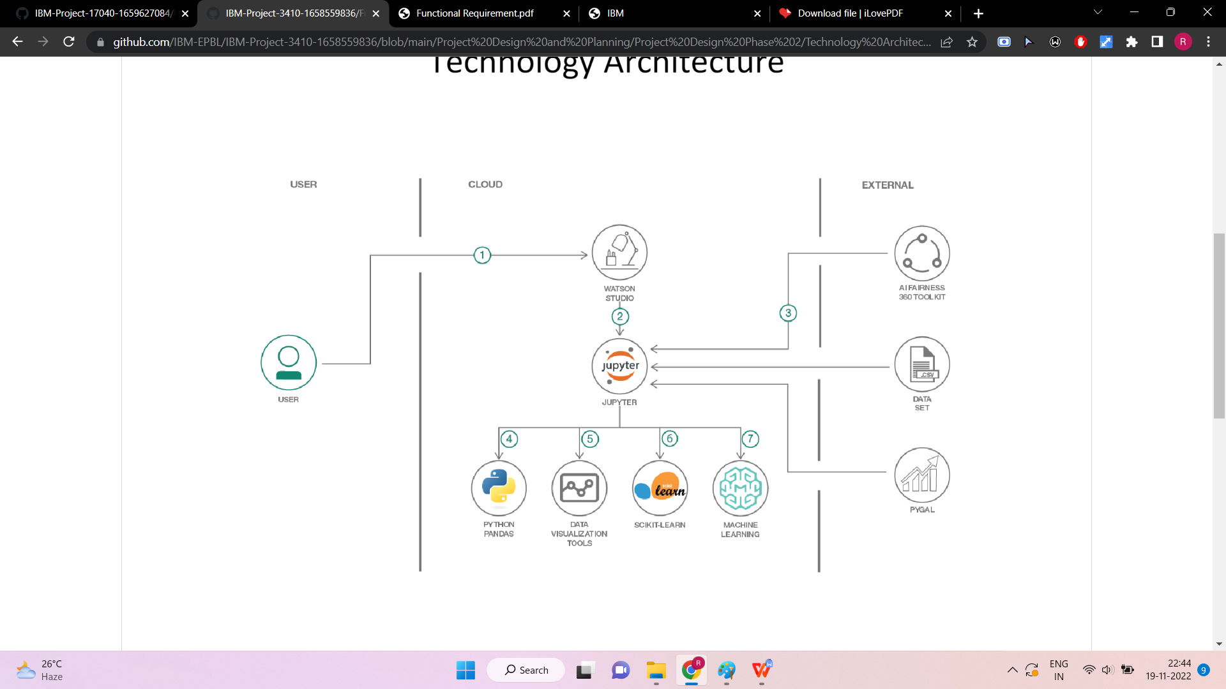

# User Stories

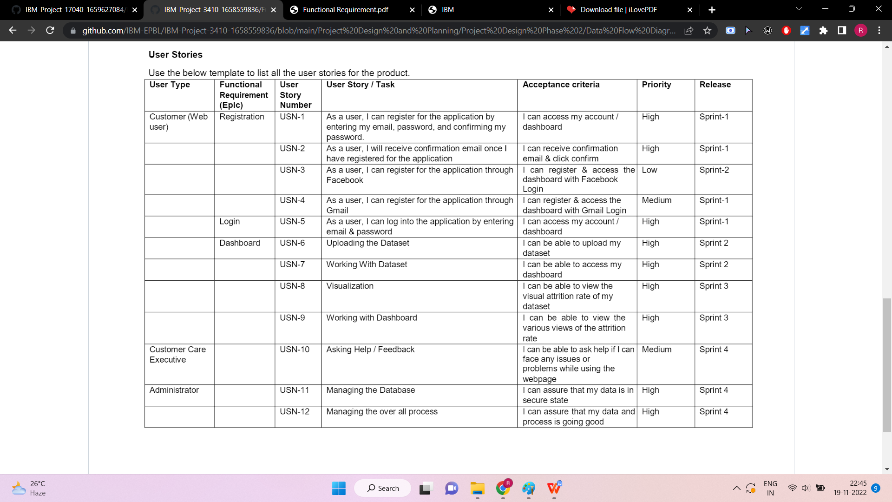

# PROJECT PLANNING

# Sprint Planning & Estimation

|  |  |  |  |  |  |  |
| --- | --- | --- | --- | --- | --- | --- |
| **Sprint** | **Functional Requirement**  **(Epic)** | **User Story Number** | **User Story / Task** | **Story Points** | **Priority** | **Team Members** |
| Sprint-1 | Login | USN-1 | As a HR, I need to give employee id and password for each employee in the organization. | 10 | High | Dakshin Aravind M,  Harsha Vardhan U, Robin Thomas T,Barath J |
| Sprint-1 | Login | USN-2 | As a HR, I’ll control the progress of each employee and the reasons leading to it like sentiment of employee, distance from home, office environment etc. And,  I’ll notify the employee with date/time. | 10 | High | Dakshin Aravind M, Harsha Vardhan U, Robin Thomas T,Barath J |
| Sprint-2 | Dashboard | USN-3 | As an employee, I’ll follow HR’s instructions to reach maximum progress by proving subsidiaries and avail help to the employee as and when needed. | 20 | Low | Dakshin Aravind M, Harsha Vardhan U, Robin Thomas T,Barath J |
| Sprint-3 | Dashboard | USN-4 | As a fellow HR, I’II gather all the Information about the emotions and sentiments to track an employee’s progress and load it into the database for  decision making. | 20 | Medium | Dakshin Aravind M, Harsha Vardhan U, Robin Thomas T,Barath J |
| Sprint-4 | Dashboard | USN-5 | As a HR head, I'll make sure everything is proceeding as planned and  without any problems | 20 | High | Dakshin Aravind M, Harsha Vardhan U, Robin Thomas T,Barath J |

# Sprint Delivery Schedule

|  |  |  |  |  |  |  |
| --- | --- | --- | --- | --- | --- | --- |
| **Sprint** | **Tot Story Points** | **Duration** | **Sprint Start Date** | **Sprint End Date(Planned)** | **Story Points**  **Completed (as on Planned End**  **Date)** | **Sprint Release Date(Actual)** |
| Sprint-1 | 20 | 6 Days | 24 Oct 2022 | 29 Oct 2022 | 20 | 29 Oct 2022 |
| Sprint-2 | 20 | 6 Days | 31 Oct 2022 | 05 Nov 2022 | 20 | 05 Nov 2022 |
| Sprint-3 | 20 | 6 Days | 07 Nov 2022 | 12 Nov 2022 | 20 | 12 Nov 2022 |
| Sprint-4 | 20 | 6 Days | 14 Nov 2022 | 19 Nov 2022 | 20 | 19 Nov 2022 |

**6.3 Reports from JIRA**

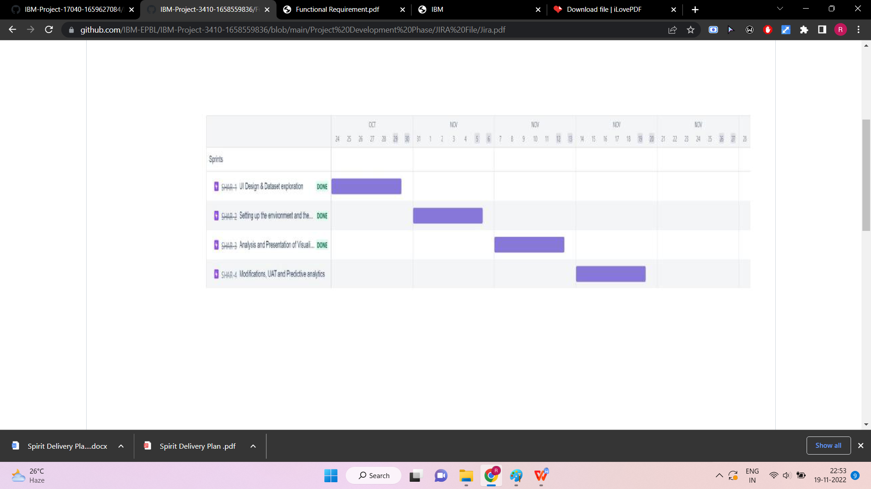

# CODING & SOLUTIONING

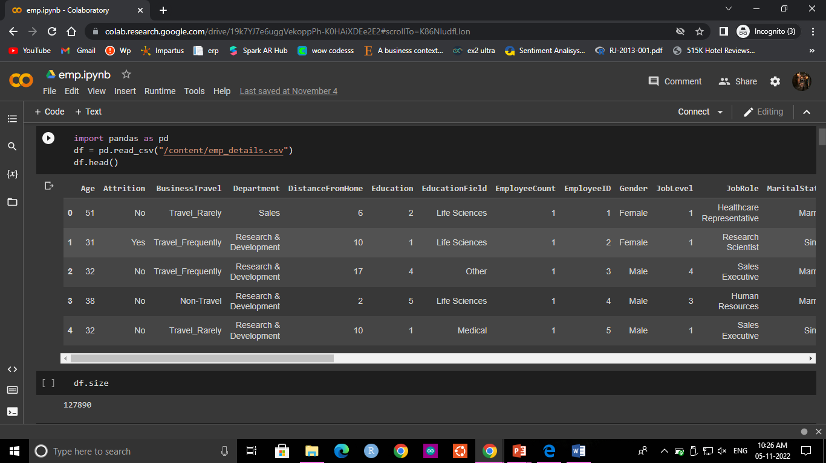

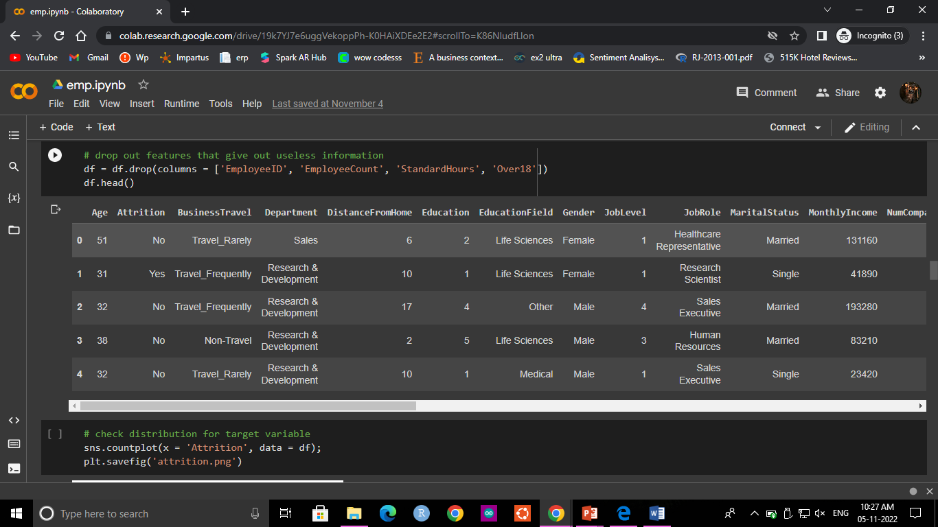

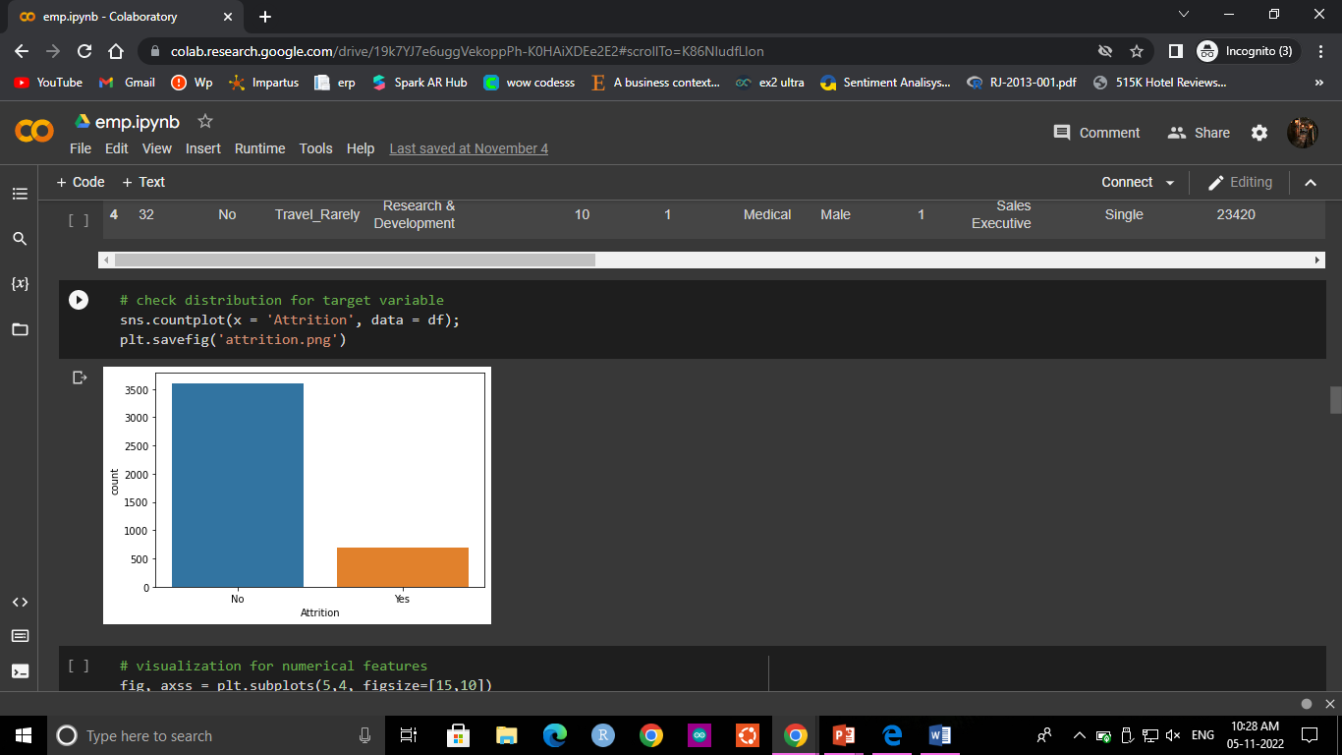

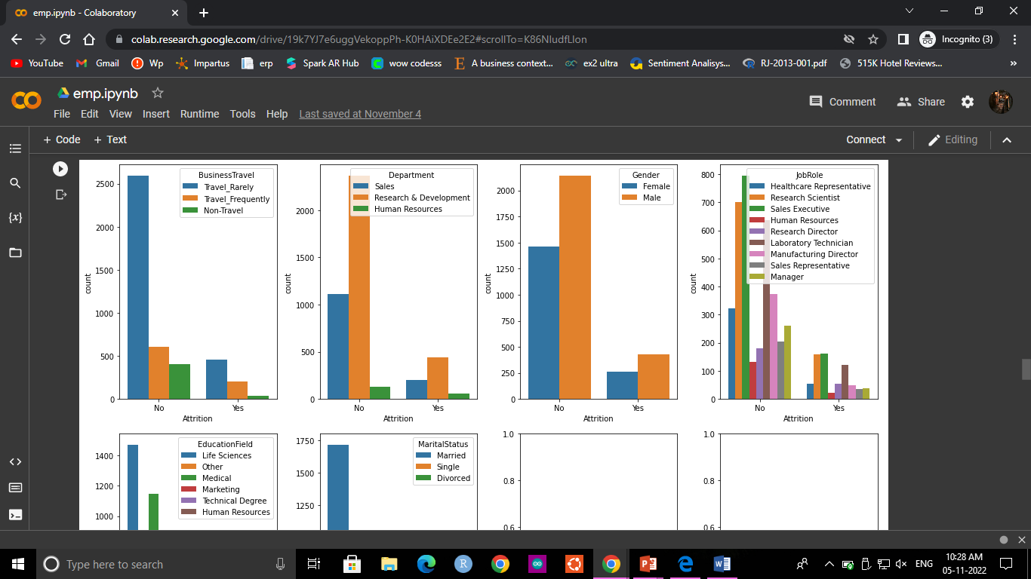

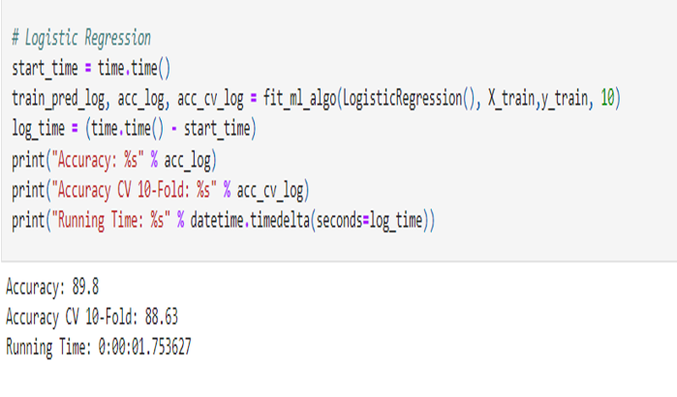

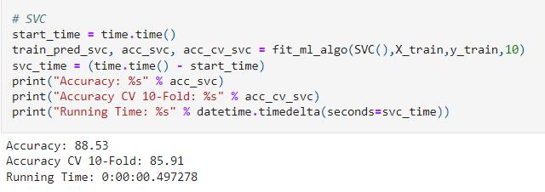

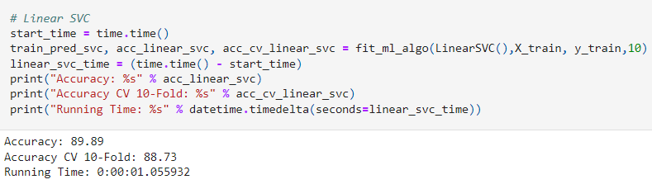

# TESTING

# User Acceptance Testing

* + 1. **Purpose of Document**

The purpose of this document is to briefly explain the test coverage and open issue of corporateemployee attrition at the time of the release.

* + 1. **Defect Analysis**

|  |  |  |  |  |  |
| --- | --- | --- | --- | --- | --- |
| **Resolution** | **Severity 1** | **Severity 2** | **Severity 3** | **Severity 4** | **Subtotal** |
| By Design | 1 | 2 | 1 | 0 | 3 |
| Duplicate | 1 | 0 | 0 | 0 | 1 |
| External | 2 | 0 | 0 | 1 | 3 |
| Fixed | 7 | 2 | 3 | 0 | 12 |
| Not Reproduced | 0 | 0 | 1 | 0 | 1 |
| Skipped | 0 | 0 | 1 | 1 | 2 |
| Won't Fix | 0 | 1 | 0 | 0 | 1 |
| Totals | 11 | 5 | 6 | 2 | 23 |

* + 1. **Test Case Analysis**

|  |  |  |  |  |
| --- | --- | --- | --- | --- |
| **Section** | **Total Cases** | **Not Tested** | **Fail** | **Pass** |
| CSV File upload | 2 | 0 | 0 | 2 |
| IBM Cognos Dashboard embedment | 5 | 2 | 0 | 3 |
| Interaction charts | 4 | 0 | 0 | 4 |
| Correlations | 1 | 0 | 0 | 1 |
| EDA | 1 | 0 | 0 | 1 |

**8.2 Model Performance Testing**

|  |  |  |
| --- | --- | --- |
| **S.No.** | **Parameter** | **Screenshot / Values** |
| 1. | Dashboard design | No of Visualizations / Graphs - 6 |

|  |  |  |
| --- | --- | --- |
|  |  |  |

|  |  |  |
| --- | --- | --- |
|  |  |  |
| 2. | Data Responsiveness | Employee Attrition by Age Attrition by Business Travel  Attrition by Department, Job Role, Education Level and Marital Status  Attrition by Salary Hike Percent Attrition by No. of Companies Worked Attrition by Income Groups Attrition by Work Experience Groups  Dashboard of Attrition of Employees based on Employment  details |
| 3. | Amount Data to Rendered (DB2 Metrics) | General_data.csv, Employee_Survey_Data.csv, Manager_Survey_data.csv |

|  |  |  |
| --- | --- | --- |
| 4. | Utilization of Data Filters | Grouping Sections Auto  general |
| 5. | Effective User Story | No of Scene Added - 8 |
| 6. | Descriptive Reports | No of Visualizations / Graphs - 6 |

|  |  |  |
| --- | --- | --- |
|  |  |  |

|  |  |  |
| --- | --- | --- |
|  |  |  |

# 9. RESULTS

**9.1 Performance Metrics**

* Quality of Work. Quality trumps quantityespecially when you consider employee productivity.
* Employee Efficiency. An efficient employee is able to maximize their productivity with minimumeffort and expense.

.

* Training Programs.
* Individual Goals

**10. ADVANTAGES &DISADVANTAGES**

**ADVANTAGES**

**Advantages of Employee Attrition**:

Not all turnovers are negative, we generally feel that an employee leaving the organization is detrimental to the organization, but there is a flip side to it.Employees leaving an organization may lead to benefits. This type of job attrition is called ‘healthy attrition’ and is needed for growth and development of an organization

**1. Higher manpower costs:**

There are times when employees stay with the organization for long, which might mean that they are getting top of their pay scale.This means that these employees are being paid a lot more than others who are doing similar job but are comparatively new in the process This excessive manpower costs leads to financial burden which is generally not identified on a regular run of the companies.

**2. Negative effect of people:**

There are some employees in an organization who work against the culture of the organization and even affect the working environment.Such employees even go to an extend to impact the loyalty of others and their outlook towards the organization.This could mean they are working against the organization from inside. When such employees leave the organization they lead to more profit than loss.

3**. New idea**:

Many a time when some people leave an organization they open gates for new talent and new ideas .Mostly employees who are in the organization get used to the working atmosphere and get complacent. This means lack of risk and definitely no new ideas.When they leave there is space for people who have high risk takingcaliber and stop the firm from becoming stagnant.

4. **Higher performance**:

There are employees who just have been working on a slow pace for years within an organization. They are reasons for poor performance and slow growth.When they leave the organization the team becomes fast paced and the turnover time is decreased considerably. This means reduced cost and satisfied clients.

5. **Setting the culture right:**

There are times that employees do not care for a lot of organization’s policies which creates a brand for the organization. When strong actions are taken against such employees like asking them to leave because they were affecting the brand name in a negative way would lead to a strong message and create a professional culture in an organization.

**DISADVANTAGES**

**Disadvantages of Employee Attrition**:

When employees leave the organization it is a loss to the company, the team and the individuals Employees are the backbone of any organization and their departing may lead to lot of various losses to company on different aspects. The disadvantages can be

**1. Decreased overall performance**:

The whole business process is affected when an employee leave the organization. It is even more risky when this happen all of a sudden.There is no time to train the new employee who is to take over the job and the whole team gets affected. It can directly be seen in an overall decrease of performance of the team.

**2. Daily task management**:

Sudden attrition may lead to difficulty in managing daily tasks. Even large organization struggle to manage their task when employees leave jobs, getting small information and managing daily tasks become difficult as they cannot be managed by small current team which is left behind.

**3. Increased cost:**

This has to be the highest disadvantage to a company when employees leave their jobs. There is increased cost associated with every level of the process – losing and paying the previous employee, hiring a new one, training cost for the new employee.Research shows that these costs are way more than the losses incurred in managing and missing out on work.

**4. Lack of knowledgeable employees**:

This goes without saying when employees leave an organization they take with them the experience they have gained overtime.Older employees with their years of experience can take over critical matters which can never be trusted with these new employees.Even with employees who have experience are hired they may suffer at taking care of critical business matter as they are new to company’s policies, culture and current employees.

**5. Create a Negative image:**

It is not just that employees are looking for job, even organizations are on the outlook of qualified professionals. When any company has high attrition rate it negatively impact the brand of the organization.Recruiters’ state that they find it difficult to map qualified candidates to the organization, as candidates opts out fearing the attrition rate. The reasons may vary but a negative image work against the organization.

**6. Employee development:**

Many organizations have various employee developent pmlans and higher attrition rate means losing out on it.

**11. CONCLUSION**

On the whole, this project was a useful experience. We have gained new knowledge and skills we achieved several of my learning goals. We got insight into professional practice. We learned the different facets of working. We experienced that self-exploration, as in many organisations, is an important factor for the progress of projects. Related to our study we learned more about employee attrition rate prediction and the various approaches and algorithms to achieve the same. There is still alot to discover and to improve. The methods used at the moment are still not standardized and a consistent method is in development. Furthermore we have experienced that it is of importance

of each strategy and how other one is better than the current algorithm and in which application. We found that the internship is not one sided, but it is a way of sharing knowledge, ideas and opinions and

implementing the same to get results. The internship was also good to find out what our strengths and weaknesses are. This helped me to define what skills and knowledge. We believe that our time spent in learning and surfing regarding various algorithms and the mathematics behind was well worth it and contributed to finding an acceptable solution to build a model and predict the employee’s attrition rate. Two main things that we’ve learned the importance of time-management skills and self-motivation. At last this project has gave us new insights and motivation to pursue a career in machine

learning domain

**12. FUTURE SCOPE**

No career growth or development opportunities: Global Talent Monitor's report on workforce activity shows that the lack of future career development remains a key driver of employee attrition — 40% of departing employees say it led them to be dissatisfied with their jobs, Gallup reports

1. **APPENDIX**

**13.1 GitHub Account Link**

<https://github.com/IBM-EPBL/IBM-Project-3410-1658559836>

**13.2 Project Demo Link**

<https://drive.google.com/file/d/18vnsl-okgUFG4ON7bBoOj_liluHxLGuI/view>